Ansible collection and Error Handling

- Custom Ansible Collection of
  - roles
  - playbook
  - error handling (block/rescue/always, ignore_errors, failed_when)
- Failure intentionally generated and handled

1: Collection Structure

- mkdir -p ansible_collections/madhuri/linuxops
- cd ansible_collections/madhuri/linuxops
- ansible-galaxy collection init .

Structure check
- tree -L 3
Output:
madhuri/linuxops/
├── roles/
├── playbooks/
├── plugins/
├── galaxy.yml
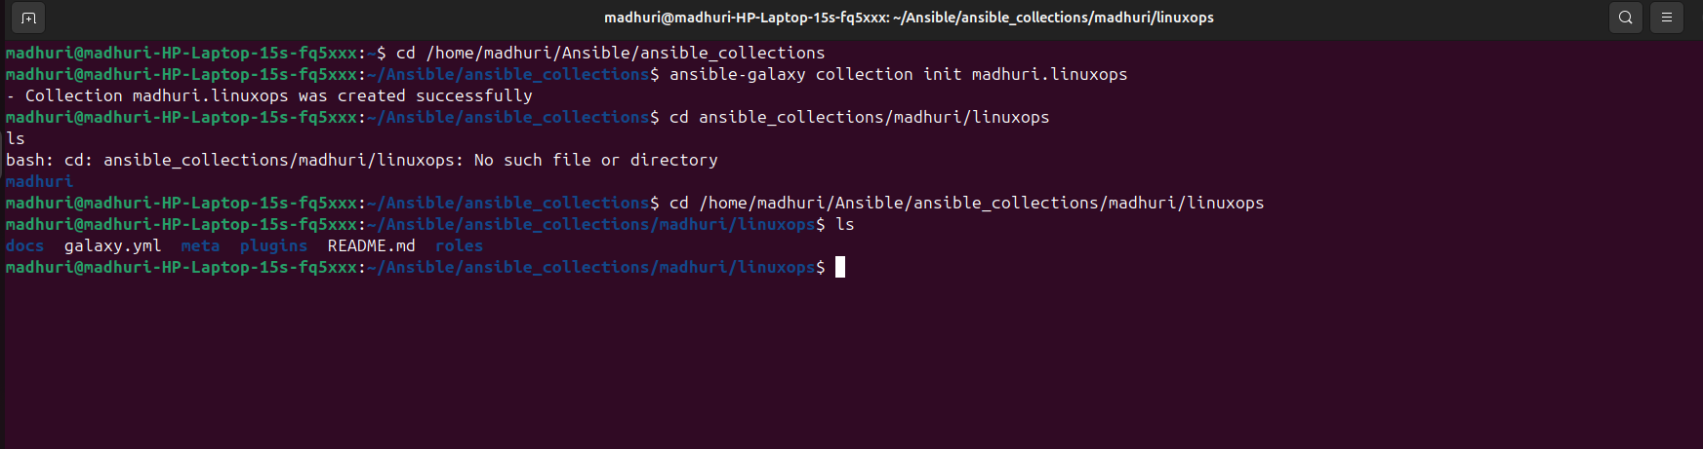
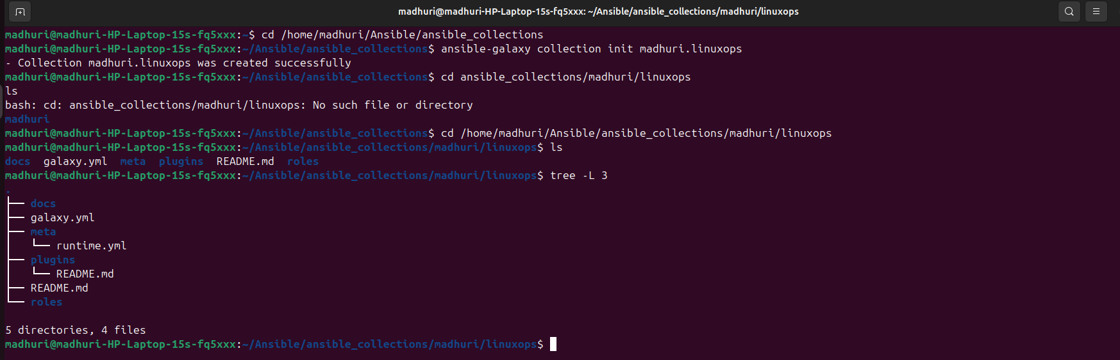

2: Role create(service manage)
- cd roles
- ansible-galaxy role init webservice


3: Intentional Failure create (ERROR SIMULATION)
roles/webservice/tasks/main.yml
- name: Install apache (will fail on purpose)
apt:
name: apache2
state: present
become: yes

- name: Start apache service (wrong name → fail)
service:
name: apache999
state: started
✔️ apache999 not exist → error
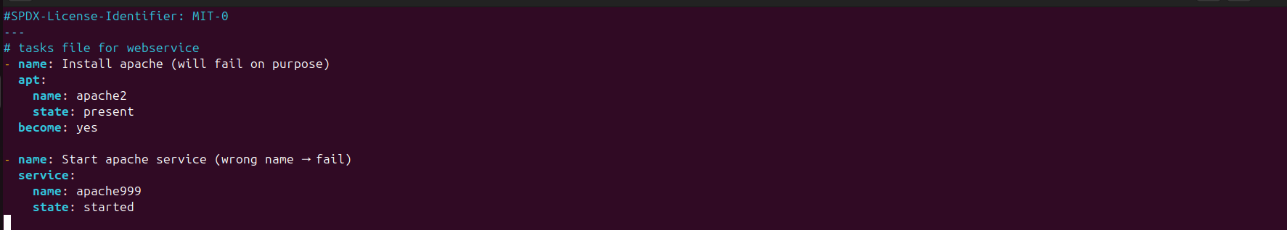

4: Playbook creation (using Collection)
- cd ../../playbooks
- touch web.yml

playbooks/web.yml
- name: Web Service Setup using Collection
hosts: localhost
connection: local
roles:
- madhuri.linuxops.webservice

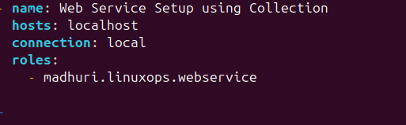

5: Run Playbook
- cd ../../..

- export ANSIBLE_COLLECTIONS_PATH=~/Ansible/ansible_collections
- ansible-playbook ansible_collections/madhuri/linuxops/playbooks/web.yml

- ansible-playbook ansible_collections/madhuri/linuxops/playbooks/web.yml --ask-become-pass

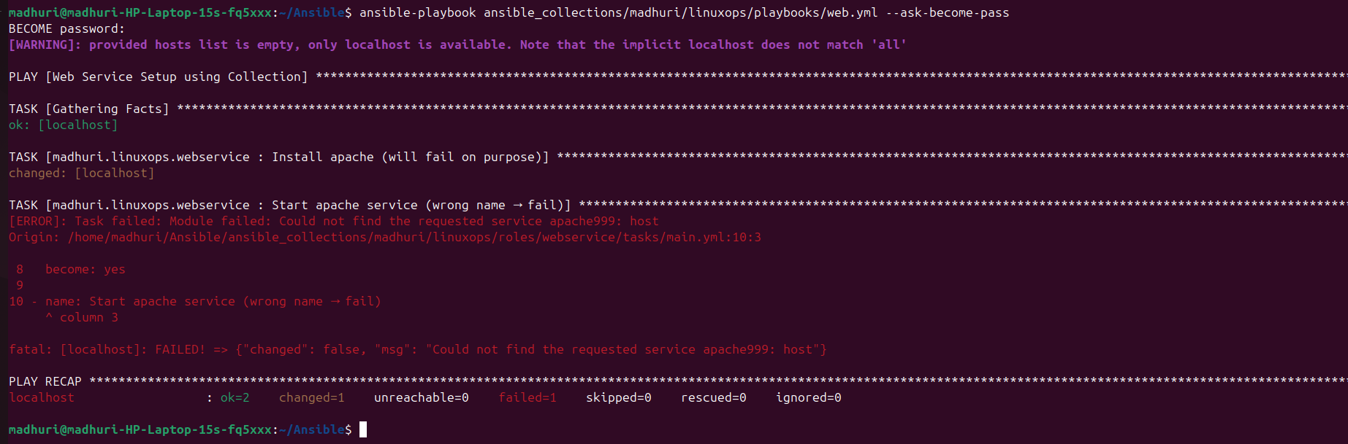

Expected Output:
- apache999 fail
- rescue block will run
- apache2 successfully start
- always block will be execute

6: Error Handling added

- block:
- name: Install apache
apt:
name: apache2
state: present
become: yes

- name: Start apache service (wrong name)
service:
name: apache999
state: started

rescue:
- name: Handle failure – log error
debug:
msg: "Apache service failed. Running rescue block."

- name: Start correct apache service
service:
name: apache2
state: started
become: yes

always:
- name: Always run this
debug:
msg: "Service task attempted."

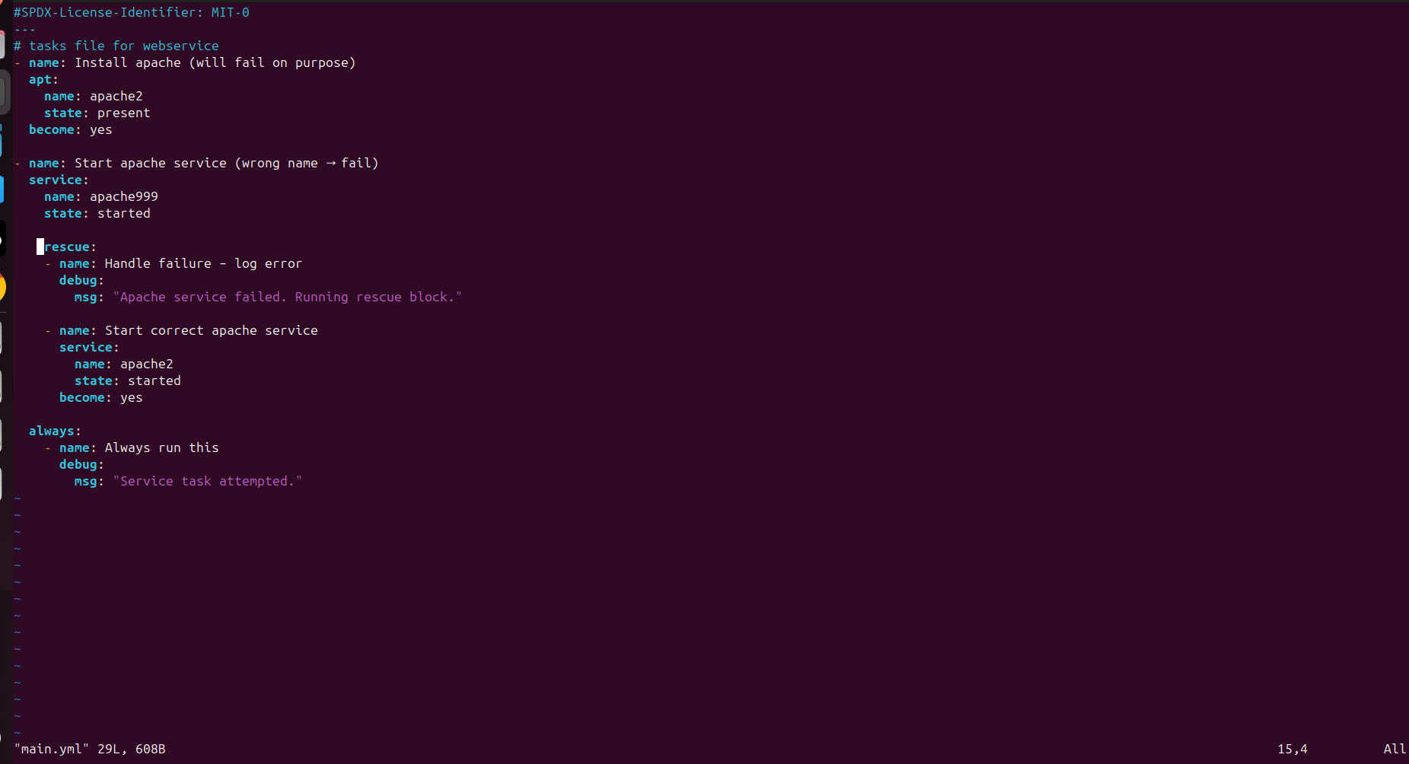
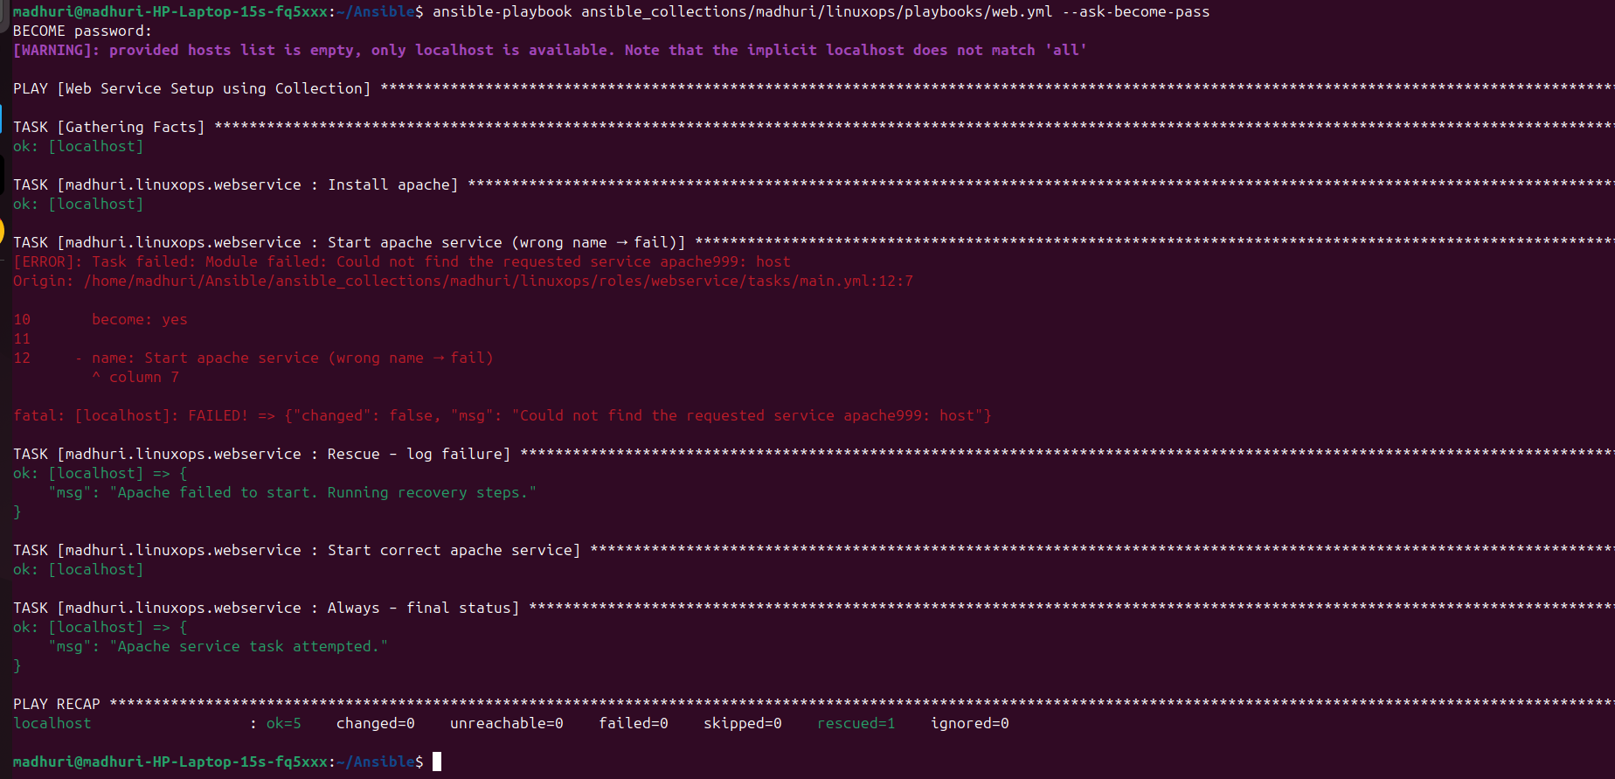

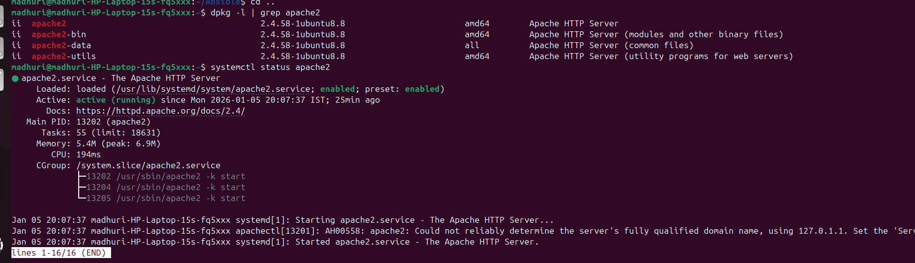

GitHub Repo Structure
ansible-collection-linuxops/
├── ansible_collections/
│ └── madhuri/
│ └── linuxops/
│ ├── roles/
│ ├── playbooks/
│ └── galaxy.yml
├── README.md

Expected behavior:
- Intentional failure occurs
- Rescue block handles it
- Apache service starts successfully
- Playbook completes without manual intervention

